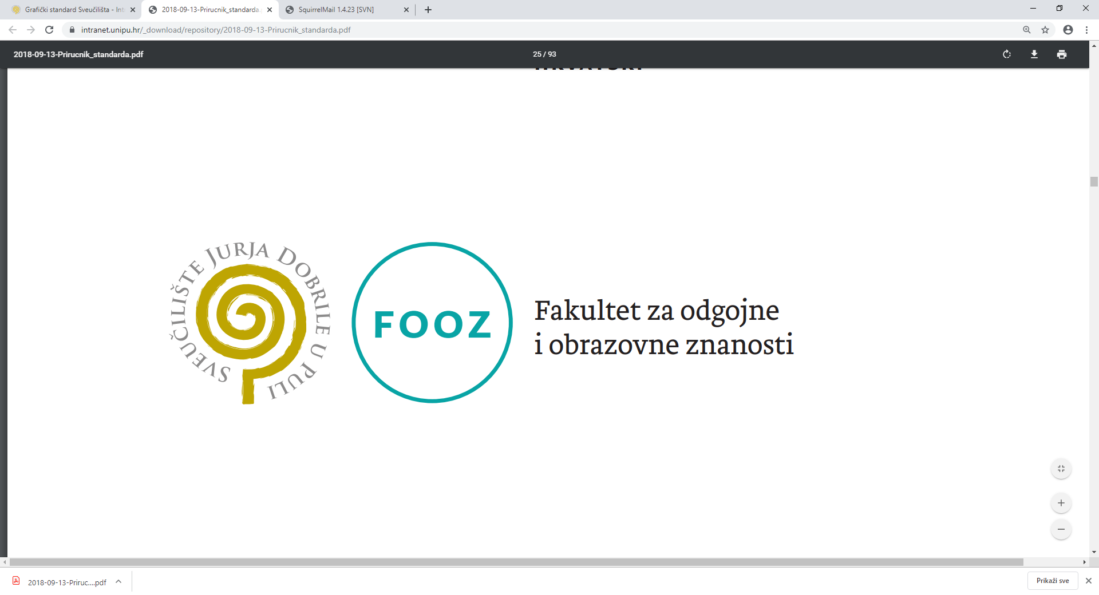

**APPLICATION FORM**

**International Scientific Conference 19th Mate Demarin Days**

**Information about the institution:**

|  |  |
| --- | --- |
| Name of institution |  |
| Address |  |
| Postal code and city |  |
| Organisation PIN |  |
| Contact telephone/mobile  phone number |  |
| Contact e-mail address |  |

**Information about the international scientific conference participant:**

|  |  |
| --- | --- |
| Name and surname |  |
| Participant’s PIN (n/a for  foreign participants) |  |
| Residence address |  |
| Postal code and city |  |
| Contact telephone/mobile  phone number |  |
| Contact e-mail address |  |

**Mark where necessary:**

□ expenses borne by institution □ e-invoice

□ expenses borne by participant

*Important notice: The invoice will be sent after we receive your application form.*

Date: ___________________ 20 _____. Authorisation of institution:

*The filled in and signed application form should be sent no later than 5 days before the defined dates (for early bird registration until 15 March 2021; after that date, no latr than 20 April 2021) to the e-mail***:** [**fooz-mdemarin@unipu.hr**](mailto:fooz-mdemarin@unipu.hr)